Practical 6

**AIM: Install Samba to share folders or files between Windows and Linux.**

STEPS TO INSTALL SAMBA AND SHARE FOLDER'S AND FILE'S:

**Step 1:** This is the basic step and should be performed every time, that is to update system repositories.

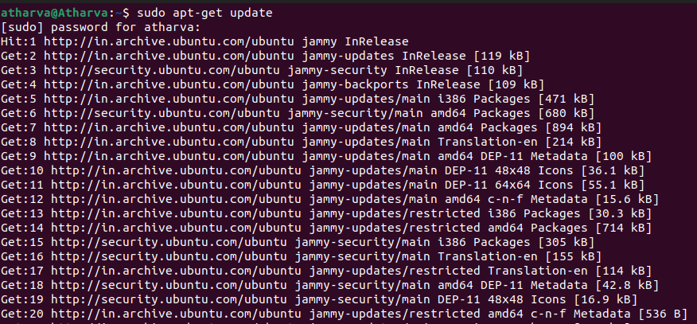sudo apt-get update

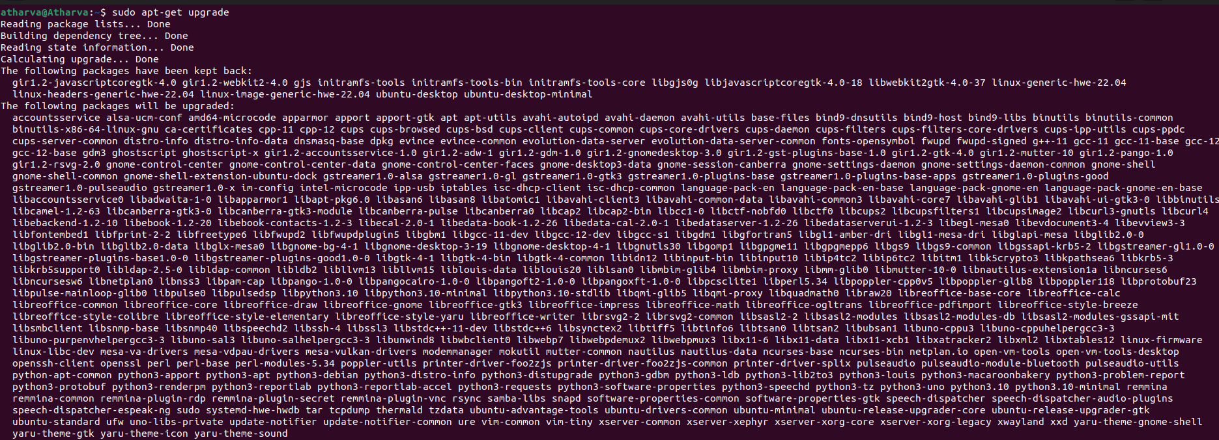sudo apt-get upgrade

**Step 2:** Now after updating system repositories next step is to install samba using command.

sudo apt-get install samba

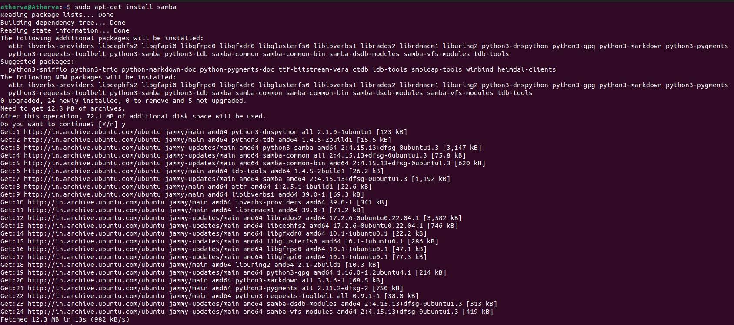

**Step 3:** Now you need to configure the shared folder so first thing you want to do is to edit the configuration file.

sudo nano /etc/samba/smb.conf

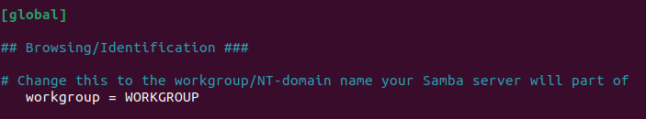

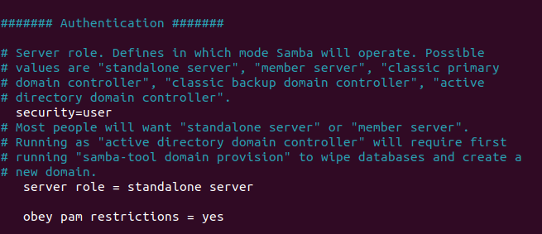

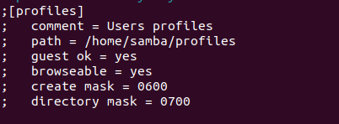

**Step 4:** Now we will make the directory and check if it's created or not.

1. sudo mkdir -p /srv/samba/share



b) cd /srv



1. Is



d) Is samba



**STEP 5:** Once you have made the directories you need to change ownership so to do that we execute the following command.

sudo chown nobody.nogroup /srv/samba/share



**Step 6:** Now we have to list the files present the directory we created, so we will use the list long command but before that we will move into the directory.

a) cd /srv/samba



1. Il

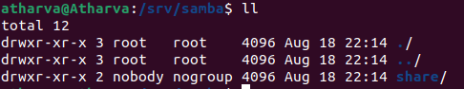

**Step 7:** Now we will configure the nmbd file for samba, for that we will use the following command.

sudo nano /etc/init/nmbd.conf

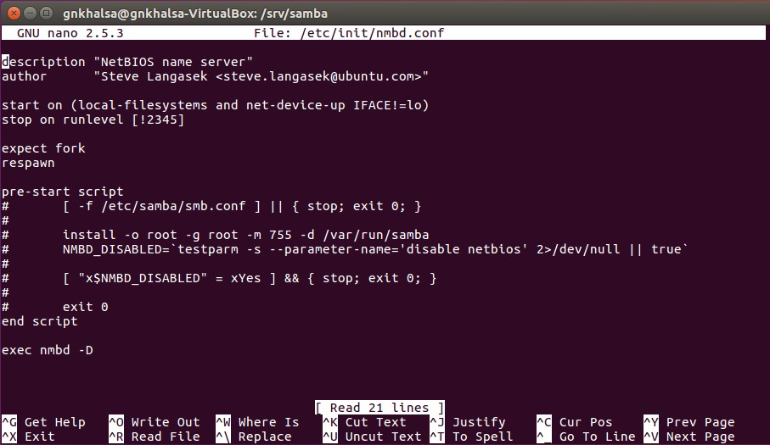

**Step 8:** Now we will restart our nmbd and smbd services using commands.

sudo service smbd restart



**Step 9:** Now create a file using touch command in /srv/samba/share named test.txt and we will check if our file is created or not.

sudo touch /srv/samba/share/test.txt



